**Date:** February 26, 2018

**To:** Shawn Janzen, Senior Data Analyst

**From:** Andrew Carroll

**RE:** The connection between drug related arrests and time of day

In 2018, the Federal Bureau of Investigation’s Uniform Crime Reporting released a report stating that a little over 1.6 million drug related arrests had taken place in the United States in 2017[1]. 1.8% of those arrests, estimated at 28,992, were in Maryland alone[2]. There is no doubt that that the number of drug arrests made in Maryland is very large and it sure has its impacts on Maryland cities and their citizens.

One area of impact that is often overlooked is the correlation between drug arrests and the time of day as well as the effects of that correlation on the community. As evidenced by our daily lives, the busiest time of the day is when schools let out, the work day ends, and rush hour starts. That is being the afternoon. We hypothesize that the majority of drug arrests occur during the afternoon. This memo will show that there is indeed such relationship among those in Baltimore City, Maryland.

|  |  |  |
| --- | --- | --- |
| **Table 1: Variable Summary** | | |
| **Offense Type** | Freq. | Percent |
| Narcotics | 1623 | 5.5% |
| Other | 27,753 | 94.5% |
| Total | 29,376 | 100% |
| **Arrest Time** | |  |
| Early Morning | 43 | 2.6% |
| Morning | 332 | 20.5% |
| Afternoon | 680 | 41.9% |
| Evening | 568 | 35% |
| Total | 1623 | 100% |

To investigate this question, we looked at police reports from Maryland’s largest city, Baltimore. We used Arrests data from the Baltimore Police Department, which contained entries from January 1st to March 18th, 2018, to look at and identify drug offenses, among the reported offenses, and the time of arrest of drug offense.

The main question we sought to resolve was “are drug offenses more likely to occur in the afternoon?” To investigate this question, we looked at the type of incident offense and the arrest time. We narrowed the incident offenses down to drug offenses. After removing the other offenses, 1483 drug offenses remained. Then, we grouped the arrest time into four categories: Early Morning (00:00-05:59), Morning (06:00-11:59), Afternoon (12:00-17:59), and Evening (18:00-23:59).

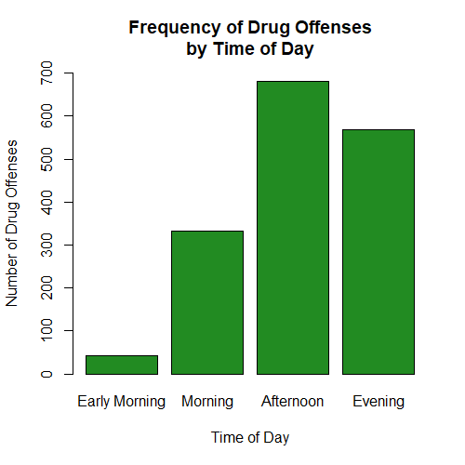The barplot measure shows that most drug offenses occur during the Afternoon (12 p.m. - 6 p.m. In addition to the evidence from the barplot, a chi-square analysis with an alpha of 0.05 reveals that these findings are statistically significant, with a chi-squared value of X2 (3, n = 1623) = 587.16, p < .05. Despite our findings in the barplot, we are able to reject our null hypothesis that most drug offenses do not happen in the afternoon with a p-value that is essentially zero (p = 2.2e -16).  The Cramer’s V effect size of 0.35 suggests that there is a moderately strong effect between the time of day and drug offense arrests. Therefore, we can confidently claim that there is some sort of correlation between time of day and drug offense arrests.

Despite our results, our study still has its’ limitations. One major limitation was measuring the arrest time rather than the offense time. Unfortunately, the time that the offense occurred was not included in the Baltimore Police Department’s data set. This poses one major problem. If the incident were to occur at 11:55 a.m. and the arrest did not occur until 12:05 p.m., then the offense would be included in the ‘Afternoon’ bin even though it occurred in the morning. This is unlikely to happen so many times that it would drastically affect our data, but with that being said it still affects our results. An updated database that includes the time of the incident would help us gain more accurate results.

1. The number of drugs related arrests in the U.S in 2017 <https://ucr.fbi.gov/crime-in-the-u.s/2017/crime-in-the-u.s.-2017/topic-pages/persons-arrested>
2. The number of drugs related arrests in Maryland in 2017 <https://ucr.fbi.gov/crime-in-the-u.s/2017/crime-in-the-u.s.-2017/tables/table-69>